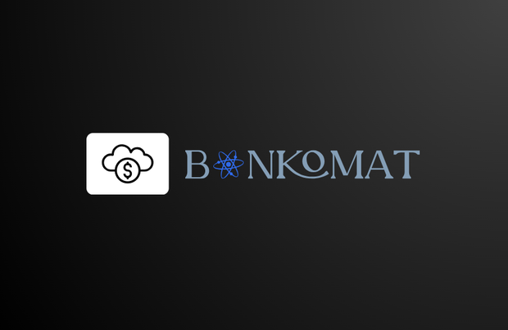BANKOMAT

**Table of Contents**

Team members 3

Topic 3

Summary 3

Stages of realization 4

Used technologies 4

Performed tasks 4

Future ideas 4

Algorithmic scheme 3

Team members

|  |  |  |
| --- | --- | --- |
| **NAME** | **CLASS** | **ROLE** |
| **Yana Zhivkova Ilcheva** | 10 V | Scrum trainer |
| **Kristian Krasimirov Gaydov** | 10 B | Back-end developer |
| **Demetra Petrova Karagyozova** | 10 G | Front-end developer |

Topic

Our project's purpose is to keep your finances save and show your purchase activity. Many people nowadays invest their money in different kinds of currencies or assets, and we want to make things easier for you with our app! It will also be possible to decide your will and choose who will the money go to after you pass away. Thank you for your trust in us and enjoy financing!

Summary

Stages of realization

Картина, която съдържа текст, екранна снимка, Шрифт, линия

Описанието е генерирано автоматично

Used technologies

* **Visual Studio** - for writing the code
* **Power Point** - for creating the presentation
* **Word** - for creating the documentation
* **Figma** - for creating the logo
* **Chrome** -for some ideas about the game and the design
* **GitHub** - for project synchronization
* **Git** -to commit our changes
* **C++** - for creating the game

Performed tasks

|  |  |
| --- | --- |
|  | Performed tasks |
| 1 | Created the basic design of the console app.  It is like an online place to enter money where bequests can also be made. |
| 2 | Created a menu.  There are three options: Log in, Register, Exit. |
| 3 | Created a submenu of the menu.  There are three options: My Balance, My will, Transactions. |
| 4 | Created a presentation, documentation, and QA documents.  Created their designs. |

Future ideas

* Customize the console app
* Upgrade the design

Algorithmic scheme

